Chapter 3, Solution 75

* Schematics Netlist *

R_R4 $N_0002 $N_0001 30
R_R2 $N_0001 $N_0003 10
R_R1 $N_0005 $N_0004 30
R_R3 $N_0003 $N_0004 10
R_R5 $N_0006 $N_0004 30
V_V4 $N_0003 0 120V
v_V3 $N_0005 $N_0001 0
v_V2 0 $N_0006 0
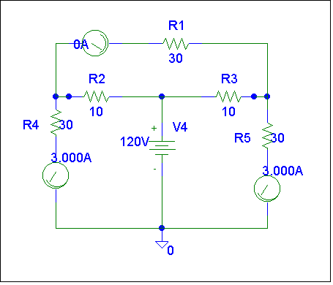
v_V1 0 $N_0002 0

i₃

i₂

i₁

Clearly, i₁ = –3 amps, i₂ = 0 amps, and i₃ = 3 amps, which agrees with the answers in Problem 3.44.

